Supplementary material

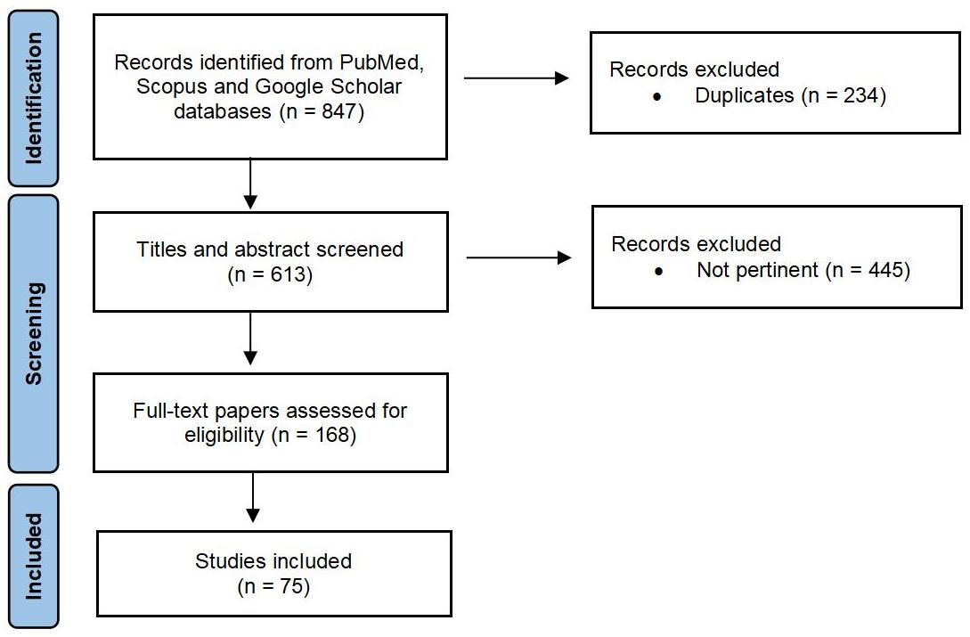

**Supplementary Fig. 1. PRISMA flow diagram illustrating the selection process of studies included in this review.** Out of 847 records identified through PubMed, Scopus, and Google Scholar, 234 duplicates were removed and 445 records were excluded based on title and abstract screening. A total of 168 full-text articles were assessed for eligibility, resulting in the inclusion of 75 studies. PRISMA 2020 flow diagram for new systematic reviews which included searches of databases and registers only.